Windowless liquid metal target concept for ESS

A. Class^{1*}, J. Fetzer¹, U. Fischer², S. Gordeev², P. Vladimirov³ , B. Weinhorst² and
R. Stieglitz²

Institute for Nuclear and Energy Technologies (IKET),
Institute for Neutron Physics and Reactor Technology (INR),
Institute for Material Sciences I (IMF-I)
Karlsruhe Institute for Technology (KIT), Hermann-von-Helmholtz-Platz 1,
D-76344 Eggenstein-Leopoldshafen, Germany
*Corresponding author: andreas.class@kit.edu

In the frame of the Design Update Phase of the European Spallation Source (ESS), the most prominent target options are analysed to select the most suitable target with respect to the neutronic and thermal hydraulic performance, reliability, maintenance, upgradeability, environmental impact, waste & decommissioning, and safety & costs. Based on previously developed liquid metal target concepts for accelerator based neutron producing facilities such as SINQ, FRANZ (GSI) and IFMIF, a novel design for a windowless lead bismuth eutectic (LBE) target is proposed for ESS by the Karlsruhe Institute of Technology (KIT).

The target module with the neutron moderators are shown in the figure below. The proton beam enters the target module through a safety window into the beam guide (vacuum) and then hits the LBE free surface. The free surface flow is generated by a nozzle and an inclined channel producing a very stable velocity profile. Successive pulses of the beam interact only with unperturbed free surfaces since waves cannot propagate upstream at the selected flow velocities of 1 to 2 m/s . The liquid metal flow is split into two streams which allows to pull the target backwards on a trolley with the moderators kept in place.

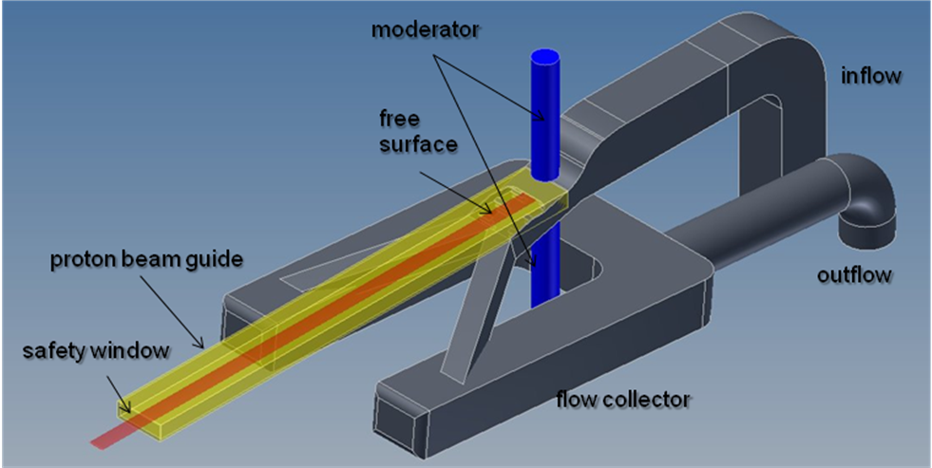

The design assumes a pool with multiple removable modules, i. e. target, heat exchanger, and pump. Since the free surface is adjacent to vacuum, the pressure within the containment is below ambient pressure. This unique feature of the free surface target minimizes the risk of any activity release. An attractive option for the start-up operation is to install a window without affecting the liquid metal flow.

The analyses include neutronic calculations with the MCNPX code, thermal-hydraulic computations with the CFD code Star-CD for simulating the free surface flow as well as material and safety related investigations which are presented in detail in the paper.

